LTspice Transformer Lab
Seth Ricks
ECEN 390
11/21/2025

ECEN 390 – LTspice Transformer Lab (60 points)
(jas, LTspice Transformer Lab.docx, 11/30/2023)

Note: This is a CAD lab to be done individually, rather than in teams, although please help each other out if/when opportunities arise, while still avoiding plagiarism. Submit an electronic version of a lab report to receive credit for doing this lab. The goal of your lab report is to provide sufficient documentation so that the lab can be repeated if necessary. Therefore, simply add to this document to arrive at your lab report, as all the explanatory text, procedures, and Discussion and Conclusion questions contained in this document are required for a complete lab report. So for your lab report, add a cover page, your results, and your answers to the Discussion and Conclusions questions to the existing lab document. Your answers to the Discussion and Conclusions questions are to be uniquely yours and not a copy of someone else’s answers to these questions. Your cover page is to include class, lab title, and author. A grading rubric for this lab is included at the end of this document. The rubric does not need to be included in your lab report.

Purpose: To better understand electrical transformers, turns ratio, reflected impedance and impedance matching.

Procedure:

Part 1 – Transformer Turns Ratio

Electrical Transformers are based on Faraday’s Law, in which changing magnetic flux caused by a changing primary current, results in an induced secondary voltage. For ideal transformers, the following relationships apply:

$$\frac{V_{s}}{V_{p}}=\frac{N_{s}}{N_{p}}, and \frac{I_{s}}{I_{p}}=\frac{N_{p}}{N_{s}},$$

where V_{s}, I_{s} and N_{s} are the secondary voltage, current and number of turns, and V_{p}, I_{p} and N_{p} are the primary voltage, current and number of turns. So stepping up the voltage from primary to secondary, steps down the current and vice versa.

This lab will utilize LTspice transformers modeled by means of coupled inductors. The inductance of a coil is proportional to the turns ratio squared. Hence, for an ideal transformer the ratio of primary to secondary inductance is given as follows:

$$\frac{L_{s}}{L_{p}}={\left[\frac{N_{s}}{N_{p}}\right]}^{2}$$

Where L_{s} is the inductance of the secondary, L_{p} is the inductance of the primary, N_{s} is the number of secondary turns, and N_{p} is the number of primary turns and. Hence, the ratio of secondary to primary inductance values are to be determined by the square of the associated turns ratio. Also, the primary to secondary voltage and current ratios are given as follows:

$$\frac{V_{s}}{V_{p}}=\sqrt{\frac{L_{s}}{L_{p}}}, and \frac{I_{s}}{I_{p}}=\sqrt{\frac{L_{p}}{L_{s}}.}$$

- Connect up the transformer circuit shown below in Figure 1. The circuit is considered electrically short and so no transmission line element is necessary. The sine wave voltage source symbol shown in Figure 1 can be found in the [Misc], library as a signal component, although the standard voltage source also works in the simulation. Hovering the cursor over this voltage source opens an Independent Voltage Source pane in which the source can be configured to produce a sine wave with parameters given in Figure 1. Resistor R1 is necessary for the simulation to properly run because it decouples Vs from L1. The net labels Vp and Vs are to be added to your schematic to aid in plotting the simulation results. Note: Resistors are 2-terminal devices, with resistors placed on schematics in LTspice have the terminals defined as pin 1 and pin 2. When placing a resistor in LTspice, the resistor first appears in a vertical orientation with pin 1 being the top terminal. Spice, and therefore LTspice, have a defined resistor current polarity as follows: Conventional current flowing into pin 1 and out of pin 2 is defined as positive, whereas the conventional current flowing into pin 2 and out of pin 1 is defined as negative. So, a current flow through a resistor that is 180˚ out of phase with the voltage across a resistor, which results in negative power dissipated by a resistor, indicates that conventional current is flowing out of pin 1. Rotating the resistor by 180 ˚ in the schematic should then result in the resistor voltage and current being in phase.
- The transformer is to be included by placing two separate inductors, with inductance values given in Figure 1. Next on the Edit pull-down menu in the upper left hand corner of the LTspice window, choose .op Spice Directive, which opens up an edit pane in which to add the following inductor coupling information: K Lp Ls 1, which couples together inductors Lp and Ls forming a transformer. Make sure your polarity dots on the coupled inductors are both on the bottom or both on the top of your coupled inductors so as to prevent a phase inversion.
- The transient analysis simulation command, i.e., .tran, can be included by means of the Edit pull-down menu followed by the choice SPICE Analysis.
- In the Edit pull-down menu, add your name to your schematic as follows: Edit Aa Text.
- When completed with your schematic, replace the schematic shown in Figure 1 below with your version, including your name. (9 points.)
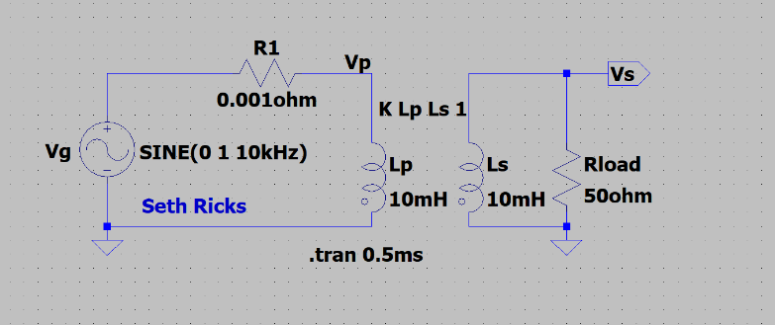
Figure 1. LTspice Transformer Simulation Circuit for Turns Ratio.

- After running the transient analysis, plot the V(Vp), V(Vs), I(Lp) and I(Ls) waveforms.
- LTspice offers built-in calculations of average and RMS (Root-Mean-Square) waveform values. These values can be obtained by hovering the mouse over the appropriate waveform label at the top of the plot pane. When the hand symbol appears while hovering over the appropriate label, hold down the Cntrl key while performing a left mouse click to open a Waveform pane indicating Average and RMS values of the chosen waveform.
- Complete Table 1 below using the built in Average and RMS (Root-Mean-Square) calculator previously described for the primary voltage V_{p_rms}, secondary voltage V_{s_rms}, primary current I_{p_rms}, and secondary current I_{s_rms}. In addition, for each L_{s}/L_{p} ratio calculate the necessary L_{s} value given L_{p} = 10 mH. Also, calculate N_{s}/N_{p} = $\sqrt{{L_{s}}/{L_{p}}}$ for each ${L_{s}}/{L_{p}}$ ratio. And finally, calculate the secondary-to-primary voltage ratio and primary-to-secondary current ratio, which should both closely correspond to the ratio N_{s}/N_{p}. Use 3 significant figures for your Table 1 values and include units where appropriate. (16 points.)
Table 1: Calculated and Simulate Values for the Transformer Circuit of Figure 1.
L_{s}/L_{p} | N_{s}/N_{p} | L_{s} | V_{p_rms} | V_{s_rms} | $$\frac{V_{s_rms}}{V_{p_rms}}$$ | I_{p_rms} | I_{s_rms} | $$\frac{I_{s_rms}}{I_{p_rms}}$$
1 | 1 | 10mH | 706.87mV | 706.87mV | 1.00 | 14.271mA | 14.137mA | 0.991
4 | 2 | 40mH | 706.83mV | 1.4137V | 2.00 | 56.58mA | 28.273mA | 0.500
9 | 3 | 90mH | 706.76mV | 2.1203V | 3.00 | 127.23mA | 42.405mA | 0.333
16 | 4 | 160mH | 706.66mV | 2.8267V | 4.00 | 226.14mA | 56.533mA | 0.250

Part 2 – Reflected Impedance

Another useful ideal transformer relationship is that between input impedance and load impedance given as follows:
$$Z_{in}=Z_{L}{\left[\frac{N_{P}}{N_{s}}\right]}^{2}.$$

This relationship implies that transformers can be used for impedance matching by means of the appropriate primary-to-secondary windings ratio. For transformers modeled in LTspice as coupled inductors, the following relationship applies:

$$Z_{in}=Z_{L}\frac{L_{p}}{L_{s}}.$$

Hence for an LTspice transformer the ratio between input and load impedance of a transformer is to be determined by means of the primary to secondary inductance ratio.

- Connect up the transformer circuit shown below in Figure 2 and run the transient analysis simulation. The circuit is considered electrically short and so no transmission line element is necessary.
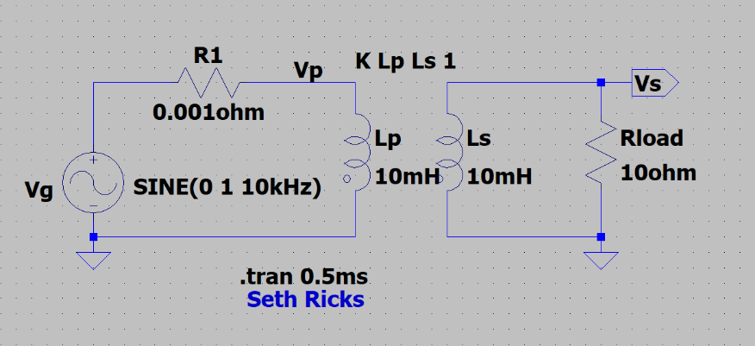
Figure 2. LTspice Transformer Simulation Circuit for Reflected Impedance.

- After running the transient analysis, the expression V(Vs)*I(Rload) is to be plotted in LTspice using Waveform Arithmetic, as briefly described below, with a detailed explanation given in the LTspice help (Help). From the Pick Visible Traces Icon in the toolbar, or under Plot Settings, select the Visible Traces icon, which opens the Select Visible Waveforms pane with all of the available voltages and currents for plotting. Explanatory text in that pane indicates to Alt-Double-Click (left mouse button) while hovering over the waveform list to open an Expression Editor pane in which arithmetic expressions can be entered. Open the Expression Editor and enter in V(Vs)*I(Rload) so as to plot the instantaneous power delivered to the load. After clicking the OK button, your entered expression shows up amongst all the rest of the circuit voltage nodes and device currents available for plotting. Also plot V(Vp), I(Lp) along with V(Vs)*I(Rload) which is the power delivered to the load, the average of which equals P_{load_av.}
- LTspice offers built-in calculations of average and RMS (Root-Mean-Square) waveform values. These values can be obtained by hovering the mouse over the appropriate waveform label at the top of the plot pane. When the hand symbol appears while hovering over the appropriate label, hold down the Cntrl key while performing a left mouse click to open a Waveform pane indicating Average and RMS values of the chosen waveform.
- Complete Table 2 below using the built in Average and RMS (Root-Mean-Square) calculator previously described for the primary voltage V_{p_rms}, primary current I_{p_rms}, and P_{load_av} equal to the average of V(Vs)*I(Rload). (Note: The power dissipated by a resistor should be positive, else the resistor needs to be rotated as explained in step 1 of Part 1.) Calculate Z_{in_sim}, i.e., the primary impedance magnitude as Z_{in_sim} = V_{p_rms}/I_{p_rms}. Also, calculate and include Z_{in_ideal} = Z_{L}(L_{p}/L_{s}). In addition, for each L_{p}/L_{s} ratio calculate the necessary L_{s} value given L_{p} = 10 mH. Use 3 significant figures for your Table 2 values and include units. (12 points.)

Table 2: Calculated and Simulate Values for the Transformer Circuit of Figure 1.
L_{p}/L_{s} | L_{s} | V_{p_rms} | I_{p_rms} | Z_{in_sim} | Z_{in_ideal} | P_{load_av}
1 | 10 mH | 706.82mV | 70.709mA | 9.996$Ω$ | 10$Ω$ | 49.96mW
2 | 5 mH | 706.86mV | 35.397mA | 19.9694$Ω$ | 20$Ω$ | 24.982mW
5 | 2 mH | 706.87mV | 14.271mA | 49.532$Ω$ | 50$Ω$ | 9.9934mW
10 | 1 mH | 706.88mV | 7.3327mA | 96.401$Ω$ | 100$Ω$ | 4.9968mW

Part 3 – Impedance Matching Transformer

When circuits are electrically short so that transmission line effects can be ignored, maximum power transfer from a practical generator to a load occurs when the load resistance equals the source resistance of the generator.

- For the circuit of Figure 3 with a generator producing a 10 V pk sine wave, calculate the rms voltage V_{load}, along with the average power delivered to the load given $P_{load_av}={V_{load_rms}^{2}}/{R_{load}}$ for R_{load} equal to 8 Ω, and then 50 Ω. Using 3 significant figures, record your calculated results below in Table 3 including units. (Note: An LTpsice simulation is not necessary for this resistive voltage divider circuit. Rather hand calculations using the relationship between peak and rms for a sinusoid are preferred for the simple circuit of Figure 3.) (4 points.)
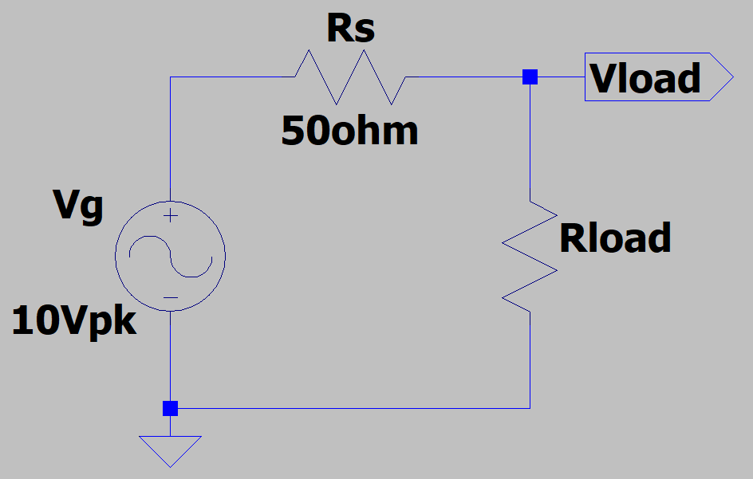
Figure 3. Generator and Load Circuit for Electrically Short Transmission Lines.

Table 3: Calculated Values for the Generator and Load Circuit of Figure 3.
$$R_{load}=8Ω→V_{load_{rms}}=\frac{Vg_{pk}\left(\frac{R_{load}}{R_{s}+R_{load}}\right)}{\sqrt{2}}=0.975V$$
$$R_{load}=50Ω→V_{load_rms}=\frac{Vg_{pk}\left(\frac{R_{load}}{R_{s}+R_{load}}\right)}{\sqrt{2}}=3.536V$$
$$P_{load_{av}}=\frac{V_{{load}_{rms}}^{2}}{R_{L}}=\frac{{0.975}^{2}V^{2}}{8Ω}=0.1189W$$
$$P_{load_av}=\frac{V_{load_rms}^{2}}{R_{L}}=\frac{{3.536}^{2}V^{2}}{50Ω}=0.25W$$

R_{load} | V_{load_rms} | P_{load_av}
8 Ω | $$0.975V$$ | 0.12 W
50 Ω | 3.536V | 0.25 W

When it is not practical to match a load resistance to a generator source resistance, then an impedance matching transformer can be used to achieve maximum power transfer to the load. As previously mentioned, for transformers modeled in LTspice as coupled inductors, the following relationship applies:
$$Z_{in}=Z_{L}\frac{L_{p}}{L_{s}}.$$

Hence an LTspice transformer can be used for impedance matching by means of the appropriate primary-to-secondary inductance ratio.

- Utilizing a primary inductance of 50 mH, calculate the necessary secondary inductance L_{s} to impedance match a standard 8 Ω speaker as the load to the signal generator with a 50 Ω output impedance. Include your calculated L_{s} value in the bottom row of Table 4 below.
$$Z_{in}=Z_{L}\frac{L_{p}}{L_{s}}$$
$$L_{s}=\frac{Z_{L}L_{p}}{Z_{in}}=\frac{8Ω*50mH}{50Ω}=8mH$$

- Next, connect up the transformer circuit shown below in Figure 4, and run the transient analysis simulation. The circuit is considered electrically short and so no transmission line element is necessary. The net label Vp is to be added to your schematic to aid in plotting the simulation results.
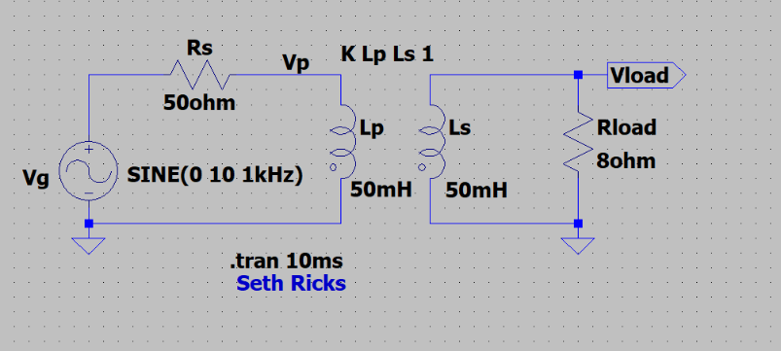
Figure 4. LTspice Transformer Coupled Generator and Load Circuit.

- After running the transient analysis, plot V(vp), V(vload) along with the expression V(vload)*I(Rload) by means of Waveform Arithmetic in the plot pane.
- Using the LTspice built-in calculator for average and RMS (Root-Mean-Square), complete Table 4 below for L_{s} = 50 mH, with P_{load_av} equal to the average of V(vload)*I(Rload). (Note: The power dissipated by a resistor should be positive, else the resistor needs to be rotated as explained in step 1 of Part 1.) Use 3 significant figures for your Table 4 values and include units. (7 points.)
- Next for the circuit of Figure 4, change the secondary inductance L_{s} from 50 mH to your previously calculated value to impedance match a standard 8 Ω speaker as the load to the signal generator with a 50 Ω output impedance.
- After running the transient analysis again, plot V(vp), V(vload) along with the expression V(vload)*I(Rload) by means of Waveform Arithmetic in the plot pane.
- Using the LTspice built-in calculator for average and RMS (Root-Mean-Square), complete Table 4 below, including your calculated L_{s} value. Use 3 significant figures for your Table 4 values and include units. Note: Your simulated average power to the load value should be approximately equal to your calculated value in Table 3 for the matched source and load impedance.

Table 4: Simulated Values for the Transformer Coupled Generator and Load Circuit of Figure 4.
L_{s} | V_{p_rms} | V_{load_rms} | P_{load_av}
50 mH | 972.87mV | 972.87mV | 118.31mW
8 mH | 3.5106V | 1.4043V | 246.49mW

Discussion and Conclusions Questions: (For the following questions use your own words along with complete sentences. Answer your questions so that readers are able to understand your response without having to read the question.)

- In your own words, explain how a transformer works using the following form of Faraday’s Law that applies for conductive loops immersed in a magnetic field:
(4 points.)
$$V_{emf}=-N\frac{dΦ}{dt}.$$
A transformer is two coils of wire on the same magnetic core. Faraday’s law in the above form states that a conductive loop immersed in a changing magnetic field will produce a voltage. Because the two wires are on the same core, there will be a voltage produced across both of them that will be proportional to one another, due to the same changing magnetic field in both of them. This yields in the turns ratio, or $\frac{V_{S}}{V_{P}}=\frac{N_{S}}{N_{P}}.$Thus, depending on the ratio of the turns, the transformer because a voltage step up or down.

- In your own words explain why a transformer doesn’t work with a DC voltage applied to the primary windings. (2 points.)
According to Faraday’s Lay of induction, a changing magnetic field over time induces a circulating electric field. The entire concept of a transformer is reliant on the facts that an induced voltage can be created in the second winding by means of the changing magnetic field. If the field is not changing, then there will be no induced electric field. The current is not changing in DC voltage, so if DC voltage is applied to the primary windings, there is no induced voltage, so there is no voltage step up or down.

LTspice Transformer Lab Grading Rubric: This is a CAD lab to be done individually, rather than in teams, although please help each other out if/when opportunities arise, avoiding plagiarism. Submit an electronic version of a lab report to receive credit for doing this lab. The goal of your lab report is to provide sufficient documentation so that the lab can be repeated if necessary. Therefore, simply add to this document to arrive at your lab report, as all of the explanatory text, procedures and Discussion and Conclusion questions contained in this document are required for a complete lab report. So for your lab report, add a cover page, your results, along with your answers to the Discussion and Conclusions questions to the existing lab document. Your answers to the Discussion and Conclusions questions are to be uniquely yours and not a copy of someone else’s answers to these questions. Your cover page is to include class, lab title, and author. The rubric below does not need to be included in your lab report.
Lab Report Item | Points
Cover Page | 2
Part 1 – Transformer Turns Ratio  Figure 1: (9 points total – 1 point for voltage source with SINE(0 1V 10kHz) configuration statement, 1 point for R1, 1 point for Rload, 2 points for correct inductor connections along with L1 = L2 = 10mH, 1 point for inductor coupling command K Lp Ls 1, 1 point for correct ground connections, 1 point for .tran 0.5m statement, 1 point for name included on schematic).  Table 1: (16 points total – 1 point per entry. -0.1 points per missing units where appropriate). | 25
Part 2 – Reflected Impedance  Table 2: (12 points total – 0.5 point per entry. -0.1 points per missing unit). | 12
Part 3 – Impedance Matching Transformer  Table 3: (4 points total – 1 point per entry. -0.1 points per missing unit).  Table 4: (7 points total – 1 point per entry. -0.1 points per missing unit). | 11
Discussion and Conclusions | 6
Grammar and Professionalism | 4
Total | 60

Please give feedback on typos, etc. you find for this lab assignment.

